How to Create a Google Account

Steps to create a Google account:
Step 1: Visit https://www.google.co.in/. Locate and select the "Sign in" button in the top-right corner of the page.
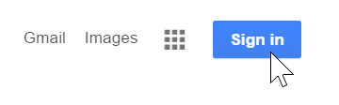
Step 2: Click Create account. A dropdown will appear asking if the account is for personal use, your child, or for work/your business. Select the appropriate option and click Next.
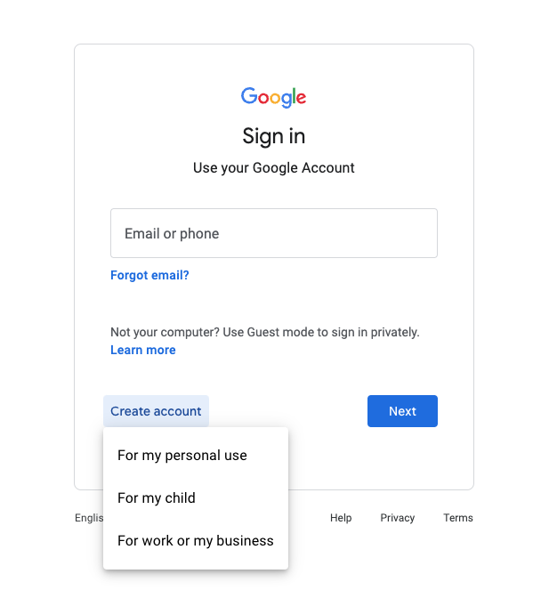

Step 3: A signup form will appear. Follow the directions by entering your first and last name and choosing a unique username. Then click Next.
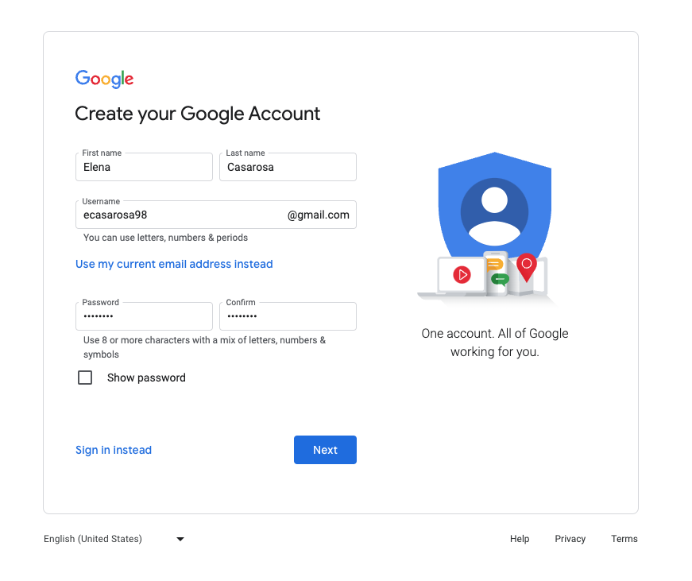

Step 4: Choose a strong password to ensure your account's security.
Step 5: The form will ask for your phone number, recovery email address, birthday, and gender. Enter this information accurately to recover your account if necessary. Click Next.
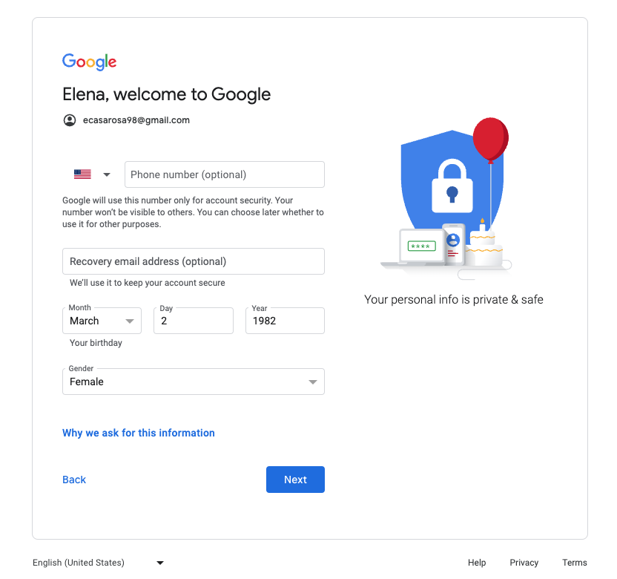

Step 6: You will be prompted to verify your phone number. Enter your phone number and click Next.
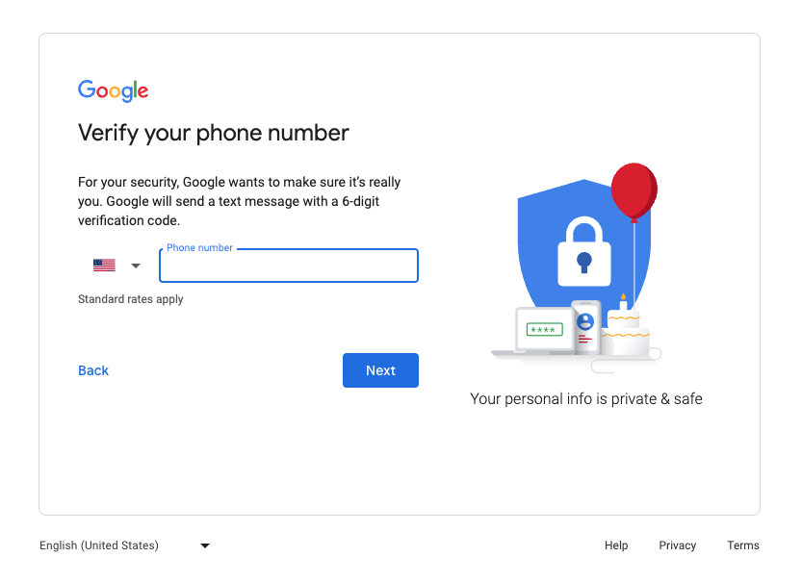

Step 7: You will see the Privacy and Terms statement. Read through it carefully. If you agree, scroll down and click the blue I agree button.
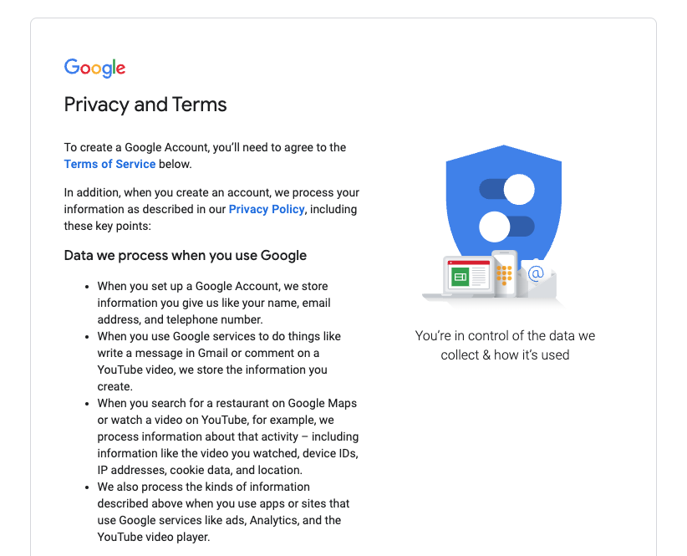

Step 8: You are now logged into Google. In the top right corner, you will see your profile icon. Click it to Manage your Google Account and add items like a profile picture.
